**Virtual Human Centred Design Course Handbook**

Table of Contents

**Total commitment for course** 2

**Set aside time** 3

**Tools for the course** 3

**Before the course begins** 3

**Kick off week** 4

**Problem definition** 5

**Interviewing development** 5

**Mock interview** 6

**Interview week** 7

**Mini showcase** 7

**Theming and insights** 8

**Design questions and communicating design** 8

**Journey mapping** 9

**Ideation** 9

**Prototyping theory** 10

**Showcase (optional)** 11

**Retrospective (optional)** 11

**Miro boards for the course** 11

# **Total commitment for course**

Over 12 weeks, there will be around 40~ hours of course work.

Course work includes:

* reviewing self-paced video content
* reading articles
* attending facilitated virtual classes
* tasks (such as interviewing users in small groups)
* reflecting on course activities

You’ll work in small teams throughout the course, so try to commit to the coursework if you can. That will help your overall group have the best learning experience. But we understand work or life may get in the way sometimes!

**Please email us if you can’t make it to a class.** We sometimes do smaller breakouts, so it helps to know if you won’t be coming or if you need to leave part way through.

To receive the course certificate the Academy requires you to attend all the classes. But sessions will be recorded, so if you need to miss one or two classes, you can catch-up and we’ll mark that as attended.

Some weeks will build upon work completed the previous week. So you’ll find the course easier if you make it too as many sessions as possible.

# **Set aside time**

You may want to set aside time for pre-learning and homework activities in your diary.

For those who like to reflect on learnings, you might like to schedule 15 minutes in your diary after each class to allow you time to reflect on learnings.

# **Tools for the course**

We’ll be using Miro every week. [Confirm you can access Miro](https://miro.com/app/board/uXjVKLo2CLw=/?moveToWidget=3458764587956439728&cot=14) on a work or home computer. Miro works best if you open it in Chrome browser.

# **Before the course begins**

Before the course starts, we encourage you to:

* [Select a topic](https://forms.office.com/Pages/ResponsePage.aspx?id=QiCd6ePBE02mDiDTuzkXfHsDhe9ysl5IlUx40xTLNQdUODVCNVRZTFdKT0RUUFg0NjUyTDhaRDlDRi4u) – early responders will get first pick so don’t delay (7 min)
* **Optional drop in session** - we hold an optional information session before the course starts, this is a chance to try out Miro and ask questions before the course.

# **Kick off week**

## **Pre-learning**

The pre-learning can be done at any time before the virtual class on that topic

* [Overview of HCD theory video](https://vimeo.com/857339617/2b40290262?share=copy) (30 min)
* Optional: [self-paced learning guide on Miro basics](https://miro.com/app/board/uXjVKLo2CLw=/?moveToWidget=3458764587956439728&cot=14) (10 min)

## **Virtual class**

* [Kick off session](https://www.apsacademy.gov.au/sites/default/files/2024-01/Kickoff%20-%20Virtual%20Class%20slides%20%28PDF%29.pdf) (120 min)

## **Homework for kick off week**

The homework can be done at any time before the following virtual class

* Desktop research on your team topic in your team Miro board (30 - 40 min)

It will look something like this:

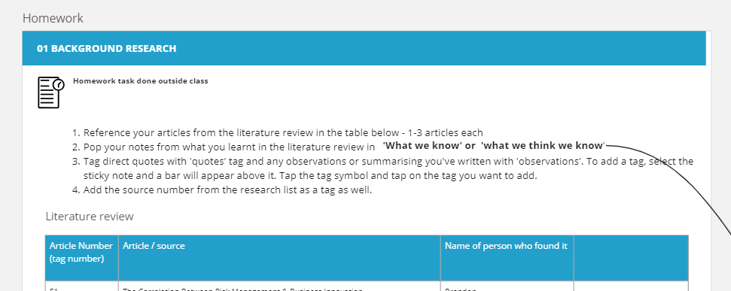

# **Problem definition**

## **Pre-learning**

The pre-learning can be done at any time before the virtual class

* [Problem definition theory video](https://vimeo.com/857340614/2bc8cb03db?share=copy) (15 min)

## **Virtual class**

* [Problem definition session](https://www.apsacademy.gov.au/sites/default/files/2024-01/Problem%20definition%20-%20Virtual%20class%20PDF.pdf) (120 min)

## **Homework**

The homework can be done at any time before the next virtual class

* *Optional homework: Refine your problem statement further*

# **Interviewing development**

## **Pre-learning**

* [Interview theory video](https://vimeo.com/866582510/1ee430a5bd?share=copy) (30 minutes)

## **Virtual class**

* [Interview development session](https://www.apsacademy.gov.au/sites/default/files/2024-01/Interviewing%20people%20PDF.pdf) (90 minutes)

## **Homework**

* You’ll be paired with 1-2 people from your team to do user interviews.
* Organise interviews together in your buddy group, so you can take turns interviewing and note taking.
* If there are 3 people in your buddy group, you should interview 3 people together. So your group will do 3 interviews in total ☺
* If you’re working in a group of 2, your group will interview 2 people in total.
* Interviews should be around 20 minutes each.

# **Mock interview**

## **Pre-learning**

Do a quick review of the below documents to get familiar with them (15 min)

* [capture sheet](https://www.apsacademy.gov.au/sites/default/files/2024-01/Interview%20capture%20sheet.pdf)
* [interview tips sheet](https://www.apsacademy.gov.au/sites/default/files/2024-01/Note%20taking%20tips%20and%20prompting%20questions.pptx)
* [consent form example](https://www.apsacademy.gov.au/sites/default/files/2024-01/Example%20research%20consent%20form.pdf)
* [example of verbal consent script](https://www.apsacademy.gov.au/sites/default/files/2024-01/Example%20consent%20script.docx)

*Optional:* [*Cognitive bias cheat sheet*](https://betterhumans.pub/cognitive-bias-cheat-sheet-55a472476b18) *(12 min)*

## **Virtual class**

* [Speed interview session](https://www.apsacademy.gov.au/sites/default/files/2024-01/Interview%20testing.pptx) (90 min)

## **Homework**

No homework for this week, other than recruit users for interviews if you haven’t already.

* *Optional homework: recording of* [*mock interviews*](https://miro.com/app/board/uXjVMqGgrVg=/?moveToWidget=3458764577246244659&cot=14) *(19 min)*
* *Optional homework: You might like put your interview questions into a word discussion guide template – see example from prototype phase of a real project*
* *Optional homework: re-visit the* [*interview tips sheet*](https://www.apsacademy.gov.au/sites/default/files/2024-01/Note%20taking%20tips%20and%20prompting%20questions.pptx) *(10 min)*
* Reminder: if you haven’t recruited users to interview yet:
* Organise interviews with your buddy/s, so you can take turns interviewing and note taking.
* If there are 3 people in your buddy group, you should interview 3 people together. So 3 interviews in total, not 9 interviews ☺
* If you’re working in a group of 2, your group will interview 2 people.

# **Interview week**

## **Pre-learning**

* *Optional pre-learning: re-visit the* [*interview tips sheet*](https://www.apsacademy.gov.au/sites/default/files/2024-01/Note%20taking%20tips%20and%20prompting%20questions.pptx) *(10 min)*

## **Virtual class**

No virtual class. There is an optional drop in session for any questions or troubleshooting.

## **Homework**

You’ll likely need to set aside 2 – 3 hours for the homework for this week, this is why there is no virtual class for this week.

* Interview users with your buddy group (take turns to lead an interview/note take)
* Capture interview notes in the [capture sheet](https://www.apsacademy.gov.au/sites/default/files/2024-01/Interview%20capture%20sheet.pdf) template
* Turn notes into post it notes in Miro (each take an interview to transcribe into Miro)

**How many people do we interview?**

If there are 3 people in your buddy group, you should interview 3 people together if you can. So 3 interviews in total, not 9 interviews ☺

If you’re working in a group of 2, your group only needs to interview 2 people.

# **Mini showcase**

## **Pre-learning**

* Interview users with your buddy (take turns to lead an interview/note take)
* Capture interview notes in the [capture sheet](https://www.apsacademy.gov.au/sites/default/files/2024-01/Interview%20capture%20sheet.pdf) template
* Turn notes into post it notes in Miro (each take an interview to transcribe into Miro)

## **Virtual class**

* Showcase impressions from interviews (60 min)

## **Homework**

No homework this week, other than pre-learning video for theming and insights class.

# **Theming and insights**

## **Pre-learning**

* [Theming and insights theory video](https://vimeo.com/866581067/f162dd184b?share=copy) (21 min)

## **Virtual class**

* [Theming and insights session](https://www.apsacademy.gov.au/sites/default/files/2024-01/Themeing%20and%20insights%20PDF.pdf) (90 min)

## **Homework**

* *Optional: Refine your themes and insights further*

# **Design questions and communicating design**

## **Pre-learning**

* [Design questions and communicating design theory video](https://vimeo.com/866581932/6107f9883e?share=copy) (20 min)

## **Virtual class**

* [Design questions and communicating design session](https://www.apsacademy.gov.au/sites/default/files/2024-01/Design%20questions%20and%20communicating%20design%20PDF.pdf) (90 min)

## **Homework**

* *Optional: Review your Miro themes and notes and tag any ‘pain points’ (15 min)*
* *Optional additional reading:* 
  + *Review* [*an example research report*](https://www.apsacademy.gov.au/sites/default/files/2024-01/Research%20report%20-%20HCD.pdf)
  + *Try an* [*empathy map*](https://www.apsacademy.gov.au/sites/default/files/2024-01/Empathy%20map%20template.pdf)
  + *Try a* [*point of view statement*](https://www.apsacademy.gov.au/sites/default/files/2024-01/Point%20Of%20View%20statement%20template.pdf)

# **Journey mapping**

## **Pre-learning**

* [Journey mapping](https://vimeo.com/875777079/95873c9dfc?share=copy) (25 min)

## **Virtual class**

* [Journey map session](https://www.apsacademy.gov.au/sites/default/files/2024-01/Journey%20mapping%20PDF.pdf) (90 min)

## **Homework**

* [Reflection survey on the course so far](https://forms.office.com/Pages/ResponsePage.aspx?id=QiCd6ePBE02mDiDTuzkXfHsDhe9ysl5IlUx40xTLNQdUNExPRzVCNkZNNzFEWVNDQVk5OUJMWlZFQS4u) (10 min)
* We ask that you also share the [manager reflection survey](https://forms.office.com/Pages/ResponsePage.aspx?id=QiCd6ePBE02mDiDTuzkXfHsDhe9ysl5IlUx40xTLNQdUOURDUUFDV084TFU0QzA0NE9FUllBWEJISi4u) with your manager or the person who approved you to go on the course.

# **Ideation**

## **Pre-learning**

* [Ideation theory video](https://vimeo.com/875776362/9777ba85f3?share=copy) (15 min)
* [Prototyping article](https://www.digital.nsw.gov.au/delivery/digital-service-toolkit/resources/user-experience-and-design/prototyping) (10 min)

## **Virtual class**

* [Ideation session](https://www.apsacademy.gov.au/sites/default/files/2024-01/Ideation%20PDF.pdf) (90 min)

## **Homework**

* Activity: Advantages and limitations of different types of prototypes - found in your team Miro board (20 min). It will look something like:

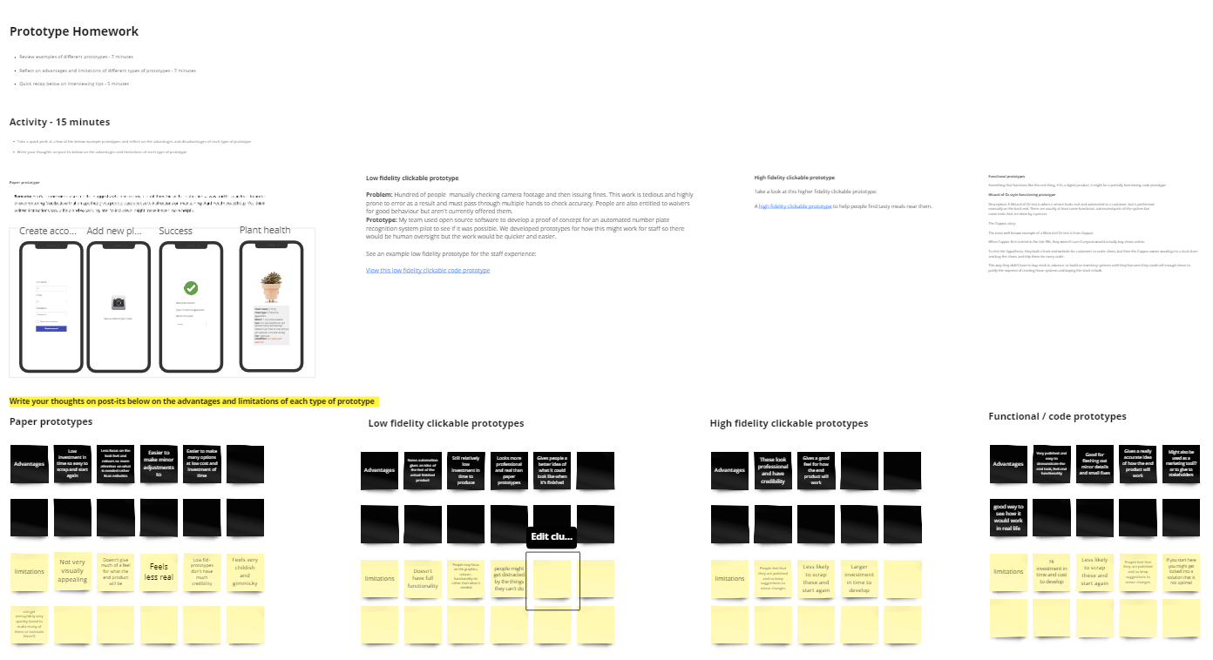

# **Prototyping theory**

## **Pre-learning**

The pre-learning can be done at any time before the virtual class

* [Prototyping theory video](https://vimeo.com/875783323/babdc802af?share=copy) (25 min)
* Review example [prototype testing script](https://www.apsacademy.gov.au/sites/default/files/2024-01/Prototyping%20script%20example.docx) (5 min)
* Activity: Advantages and limitations of different types of prototypes - found in your team Miro board (20 min).

It will look something like:

## 

## **Virtual class**

* [Prototype development and testing](https://www.apsacademy.gov.au/sites/default/files/2024-01/Prototyping%20theory%2C%20development%20and%20testing%20PDF.pdf) (2.5 hours)

## **Homework**

There is no homework for this week but you may want to review your learnings from the session for showcase. This will be a casual session to playback what you learnt with people from the APSC and other people interested in taking the course in future.

# **Showcase (optional)**

For showcase we’ll invite people from outside the course, so you can practice with a real (but friendly) audience. We’ll also have people that put forward topics for each team to explore. You’re also welcome to forward the invite to your team.

## **Pre-learning**

* [Pitches, Delivery and Showcase](https://vimeo.com/875787017/4085c234ee?share=copy) (21 min)

## **Virtual class**

* [Showcase and retrospective](https://www.apsacademy.gov.au/sites/default/files/2024-01/Showcase%20%28PDF%29.pdf) (90 min)

# **Retrospective (optional)**

## **Pre-learning**

* [Reading on retrospectives](https://www.digitalprofession.gov.au/guides-and-resources/modern-ways-working/agile/retrospectives) (10 min)

## **Homework**

* Reflection is a core practice in human centred design.
* If you have 15 minutes please take some time to fill out the [course reflection survey](https://forms.office.com/Pages/ResponsePage.aspx?id=QiCd6ePBE02mDiDTuzkXfHsDhe9ysl5IlUx40xTLNQdUOERRSFVZWUZSSjFHTlFYWDdRN0VBMzBLMi4u).

# **Miro boards for the course**

You’ll be placed in a team for the duration of the course and assigned a Miro board in the first virtual class. For future reference, all the team Miro boards are below:

* [Team #1 Miro Board](https://miro.com/app/board/uXjVN15aJ6M=/?moveToWidget=3458764576755385633&cot=10)
* [Team #2 Miro Board](https://miro.com/app/board/uXjVN1Dy2Hk=/?moveToWidget=3458764576771147050&cot=10)
* [Team #3 Miro Board](https://miro.com/app/board/uXjVN1Dy0KE=/?moveToWidget=3458764576771530402&cot=10)
* [Team #4 Miro Board](https://miro.com/app/board/uXjVN1Dy0FA=/?moveToWidget=3458764576771314715&cot=10)
* [Ideation board](https://miro.com/app/board/uXjVN19XG1Q=/?moveToWidget=3458764576768250250&cot=14)